**CST8912 – Cloud Solution Architecture**

**Cloud Development and Operations**

**CST8912_013 Cloud Solution Architecture**

**Lab 3_Week 4**

**Prepared By: Submitted to:**

**Daniyal Shahid (041110791) Prof. Ragini Madan**

**CST8912 – Cloud Solution Architecture**

**Graded Lab Activity #3**

**Purpose of this hands-on Lab that can be simulated in any CSP**:

In this lab, you will explore the Azure storage account, and generate shared access signatures for Azure Cloud, how to change rules and conditions to manage lifecycle of cloud storage

1. Create a storage account “labtest8912” under student subscription and resource group “CST8912-demo” for region Canada central and select geo redundant storage (geo redundant storage GRS), keep networking and data protection options default /2   
     
   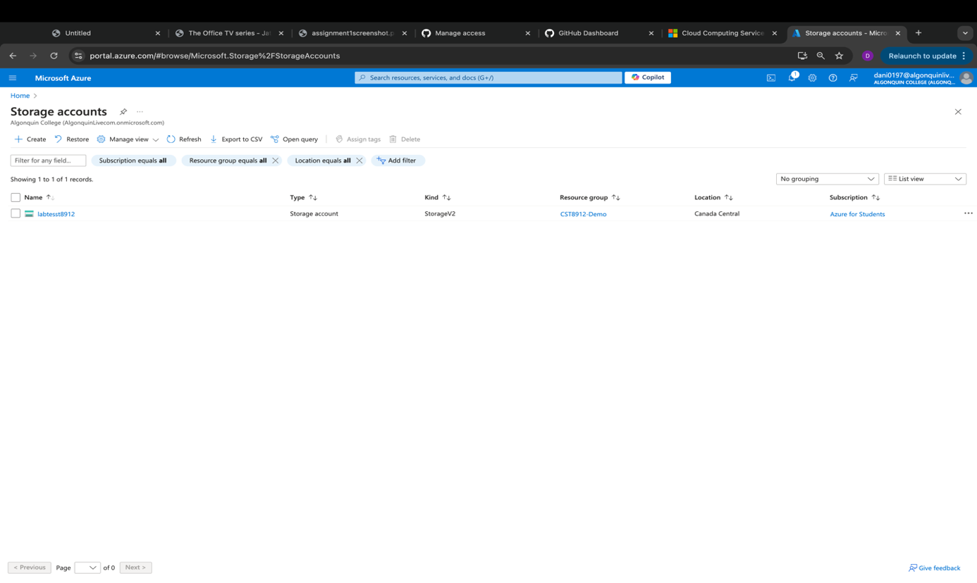
2. Go to your storage account resource blade, in data management section, go to redundancy tab and change redundancy to “local redundant storage” from dropdown, and under settings choose configuration and set blob access tier to cool and save the change /2  
     
   A screenshot of a computer

   Description automatically generated  
     
   A screenshot of a computer

   Description automatically generated
3. under data storage in left, click containers and add new container named “labtestcontainer8912” and select upload a blob and change the advance settings and change the access tier to “hot” and upload to folder named “sampletest8912”, browse the files from the sample files links shared in this lab (check with your instructor if you cannot find the sample file link) /6  
     
   A screenshot of a computer

   Description automatically generated  
     
     
     
   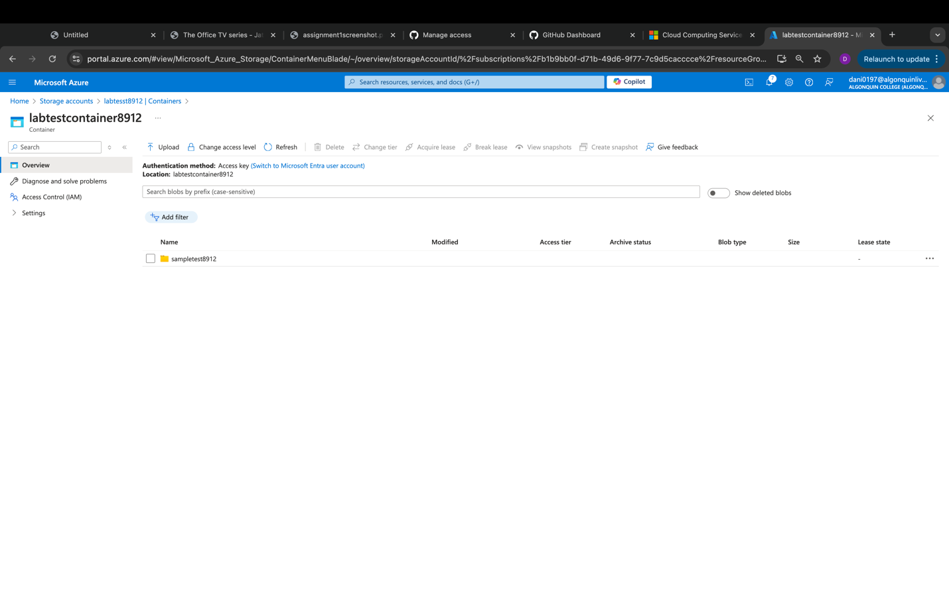
4. click the file uploaded in the container to see the configuration options and copy the blob url and open a new private window from the browser to paste the copied url

note : The url should not work since the containers public access is set to private, resource was not found. /2   
  
1. On the file blade, click generate SAS and copy the SAS token generated and paste the blob SAS URL on the private window of the browser, you must be able to see the file /3  
     
   A screenshot of a computer

   Description automatically generated  
   A screenshot of a computer

   Description automatically generated
2. On the container blade under data management tab go to “Lifecycle Management” and create a new rule name “myrule8912”, rule scope should be “limit blobs with filters” and blob type and blob subtype should be default, add condition if base blobs were last modified more than “ 15 days” ago then “move to cool storage” /4  
     
   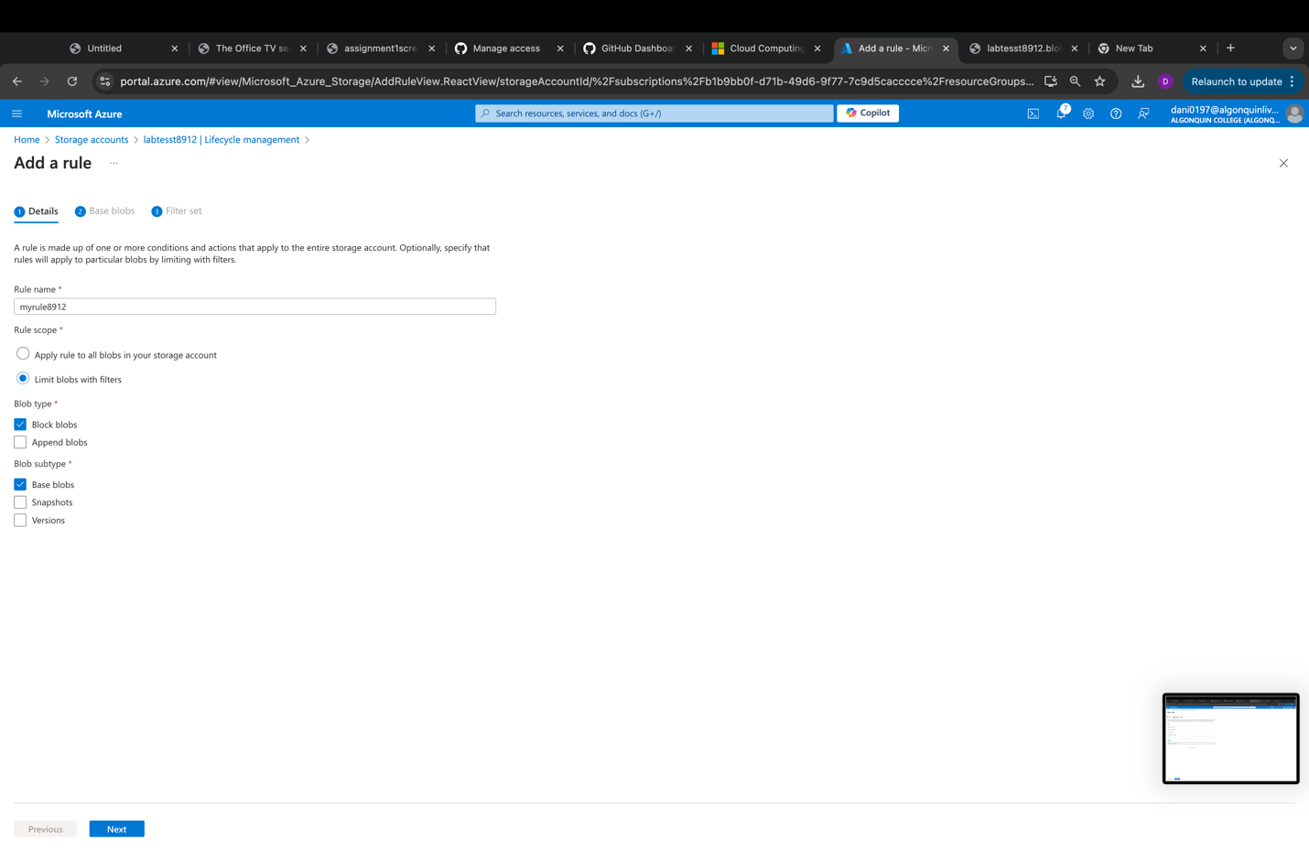  
     
   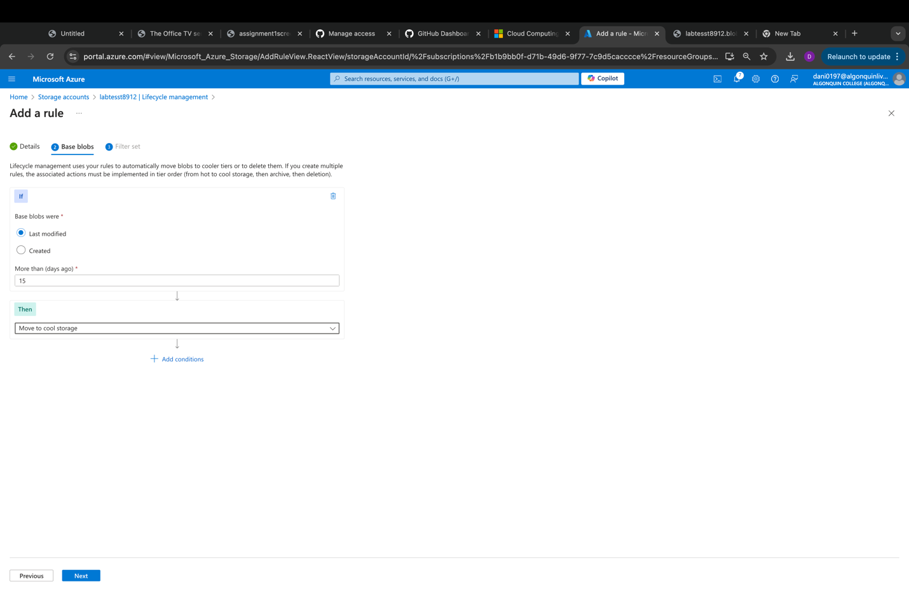  
   A screenshot of a computer

   Description automatically generated
3. After demo delete all the resources created during lab and create a lab report documenting all the steps with screenshots /1   
     
   A screenshot of a computer

   Description automatically generated